

*meesho*

**Product Dissection for Meesho**

### **Company Overview**

### In a digital marketplace dominated by e-commerce giants, one Indian startup has redefined online selling—**Meesho**. As a pioneer in **social commerce**, Meesho empowers entrepreneurs to build businesses with just a smartphone and a vision.

### Founded in **2015** by **Vidit Aatrey** and **Sanjeev Barnwal**, Meesho—short for **Meri Shop**—is headquartered in **Bangalore, Karnataka**. The platform seamlessly connects suppliers, resellers, and customers, leveraging **social media channels** like WhatsApp, Facebook, and Instagram for marketing and sales.

### Meesho offers an **affordable and accessible** shopping experience across categories like fashion, beauty, and home essentials. By eliminating high investment barriers, it has enabled millions of individuals to launch their own online businesses. Unlike traditional e-commerce platforms, Meesho focuses on **advertising and financial services to generate income**, allowing them to keep prices exceptionally low for their consumers.

### With over **120 million monthly active users** and a Gross Merchandise Value (GMV) **exceeding $5 billion**, Meesho is one of **India’s fastest-growing e-commerce platforms**. Its innovative approach and commitment to small businesses have cemented its status as a major industry player.

### **Product Dissection**

Meesho has disrupted India’s e-commerce industry by democratizing online selling through a zero-investment social commerce model. The platform's key functionalities are designed to empower small business owners, homemakers, and first-time entrepreneurs by removing traditional barriers like inventory management, marketing costs, and logistical challenges.

Meesho's success is attributed to several user-centric features. Key functionalities include:

* **Reseller Model:** Users can resell products from Meesho’s catalog and earn a margin on each sale.
* **0% Commission Fee:** Meesho allows suppliers to keep 100% of their profits by eliminating commission fees.
* **Social Commerce Integration:** Meesho simplifies selling through social media platforms like WhatsApp and Facebook, leveraging the power of personal networks for business growth.
* **Cash-on-Delivery (COD) and Easy Returns:** By offering customer-friendly payment and return options, Meesho builds trust among first-time online shoppers.
* **Localized Product Recommendations:** Meesho tailors its product offerings to suit regional tastes and preferences, making it relatable and attractive to diverse markets in India.
* **Accessible and Intuitive User Interface:** The platform’s user-friendly design ensures inclusivity, even for those with minimal technological literacy.

### **Case Study: Real-World Problems and Meesho's Innovative Solutions**

Meesho, as an Indian e-commerce platform, has encountered several real-world challenges while striving to empower small businesses and entrepreneurs.

#### **Problem 1: Barriers to Entry in E-Commerce for Small Entrepreneurs**

**Real-World Challenge**

In 2015, India’s e-commerce landscape was dominated by giants like Flipkart and Amazon, making it difficult for small businesses, local shop owners, and individuals—especially homemakers and students—to establish an online presence. High setup costs, lack of technical expertise, and limited access to logistics and supply chains created significant barriers to entry, preventing millions from tapping into the digital marketplace.

**Meesho's Solution: *Enabling Social Commerce***

Recognizing this untapped opportunity, Vidit Aatrey and Sanjeev Barnwal set out to bridge the gap. In 2015, Vidit and Sanjeev officially launched Meesho as a mobile app. The app’s user-friendly interface allowed resellers to

* Discover products easily
* Set their own profit margins
* Share product listings on their social media accounts like WhatsApp, Facebook, and Instagram.
* Let Meesho handle the order fulfilment process, including packaging and delivery, freeing resellers from logistical challenges.

**Impact:** Millions of small business owners and homemakers could now enter the digital market.

#### **Problem 2: High Selling Costs for Small Businesses**

**Real-World Challenge**

Before Meesho introduced its zero-commission model, small businesses and independent sellers struggled with high commission fees charged by traditional e-commerce platforms. These fees reduced their profit margins, making it difficult for them to compete and grow online. Many sellers, especially those with low investment, could not afford these extra costs, discouraging them from selling online.

**Meesho's Solution: *Zero Commission Fee***

To help small businesses succeed, Meesho removed commission fees, **allowing sellers to keep 100% of their earnings**. This attracted more sellers to the platform, enabling them to offer lower prices to customers while still making a profit.

**Impact:** By eliminating commission charges, Meesho made online selling more accessible, helping millions of small businesses grow without financial barriers.

**Problem 3: Trust Issues Among First-Time Online Shoppers**

**Real-World Challenge**

Many potential users in smaller towns struggled with trust issues regarding online platforms. Lack of awareness and unfamiliarity with e-commerce created apprehension about online transactions, particularly around payment security and product quality.

**Meesho's Solution: *Customer-Friendly Features***

Meesho addressed these concerns by introducing:

* **Cash-on-Delivery (COD):** Offering COD as a payment option assured users of safe transactions.
* **Easy Returns**: A streamlined return process improved customer confidence.
* **Social Selling Model:** Leveraging platforms like WhatsApp and Facebook allowed customers to interact with trusted resellers directly, reducing hesitation.

#### **Impact:** Higher adoption rates among first-time buyers and a growing loyal customer base.

#### **Problem 4: Financial and Economic Empowerment for Women**

**Real-World Challenge**

Women, particularly homemakers, often lacked opportunities for financial independence due to societal and structural barriers. Many were seeking flexible ways to earn income while managing household responsibilities.

**Meesho's Solution: *Empowering Women Entrepreneurs***

Meesho enabled women to become resellers through its zero-investment business model. The platform allowed them to:

* Work **flexible hours and run businesses from home**.
* Leverage social networks to market products and earn profit margins.
* **Access training and resources** provided by Meesho to grow their businesses.

**Impact:** Over 60% of Meesho’s resellers are women, contributing to financial independence and economic empowerment.

#### **Problem 5: Logistics and Inventory Management for Small Businesses**

**Real-World Challenge**

Small businesses and independent sellers lacked access to reliable logistics networks and faced challenges managing inventory.

**Meesho's Solution:** ***Streamlining Operations***

Meesho simplified logistics by handling:

* **Order Packaging and Delivery:** Sellers didn’t need to worry about shipping or delivery services, as Meesho provided end-to-end support.
* **Inventory-Free Selling:** The reseller model allowed users to sell products without maintaining inventory, reducing risks and overhead costs.

**Impact:** This approach alleviated logistical burdens and empowered sellers to focus on sales and customer engagement.

**Problem 6: Online Fraud and Scams**

**Real-World Challenge**

Online fraud and scams have become a growing concern in e-commerce, affecting both customers and sellers. Fraudulent activities such as fake orders, account takeovers, and lottery scams erode user trust and create financial losses.

**Meesho's Solution: *Project Vishwas***

* **Advanced Fraud Detection:** Developed AI-driven risk models to identify and block suspicious transactions.
* **Blocking Fake Orders:** Prevented 13 lakh bot orders and 77 lakh scam attempts using data-driven security measures.
* **Legal Action Against Fraudsters:** Collaborated with law enforcement to file FIRs against over 40 suspects involved in fraudulent activities.
* **Rapid Customer Support:** Launched a Quick Response Team that provides fraud-related assistance within 5 minutes via the Meesho app.
* **Removing Fake Websites & Social Media Scams:** Took down 18,000 fraudulent social media accounts and 130 fake websites/apps misusing Meesho’s brand.
* **Legal Protection:** Obtained a High Court ruling recognizing Meesho as a "well-known mark," allowing the company to deactivate fraudulent sites and freeze bank accounts linked to scams.

**Impact:** Reduced lottery fraud by 75%, prevented 2.2 crore fraudulent transactions, and ensured a safer platform for both resellers and customers

**Conclusion**

Meesho’s journey from a **small startup to a leading e-commerce platform** highlights its ability to recognize real-world challenges and implement innovative solutions. By eliminating commission fees, optimizing pricing, enhancing trust and safety, and leveraging technology to combat fraud, Meesho has empowered small businesses and entrepreneurs across India. Its user-centric approach, data-driven strategies, and continuous innovation have positioned Meesho as a game-changer in the e-commerce space, making online selling more accessible, affordable, and secure for millions.

### **Top Features of Meesho**

* **Customers:** Customers who create an account to place orders on the online shopping platform.
* **Suppliers:** Sellers who provide products on the platform.
* **Products:** Represents the set of products available for purchase on the platform.
* **Category:** Products are categorized into different sections such as clothing, electronics, and home decor, enabling easier navigation.
* **Orders**: Users can place orders for products. Orders track the status from placement to delivery, ensuring smooth transactions.
* **Order_item:** Each item that is part of an order.
* **Payment:** The payment made by the customer once the order is completed.
* **Shipment:** Shipping information associated with an order, including delivery address and tracking information.
* **Cart:** The customer’s virtual basket or shopping cart, which stores items before they are purchased and become part of an order.
* **Wishlist:** Stores items chosen by the customer for possible future purchases.
* **Reviews & Ratings:** Users can review and rate products based on their experiences, helping others make informed purchasing decisions.

**Schema Description**

Meesho's schema consists of multiple entities representing different aspects of the platform. These include Customer, Products, Orders, Order Details, Cart, Payments, Shipment, Reviews, Wishlist, and Categories. Each entity has specific attributes that describe its properties and relationships with other entities.

**Customer Entity:**

The Customers entity represents users who create an account to place orders.

* **CustomerID (Primary Key)** – A unique identifier for each user.
* **First_name** – First name of the customer.
* **last_name –** First name of the customer.
* **Email –** Email address used for login and communication.
* **PhoneNumber –** Customer’s contact number.
* **Password –** password for the account.
* **Address –** Default delivery address.
* **Registration_Date** – The date when the user joined Instagram.

**Suppliers Entity:**

The Suppliers entity represents sellers who provide products on the platform.

* **SupplierID (Primary Key)** – Unique identifier for each supplier.
* **Name** – Name of the supplier/business.
* **Email** – Supplier’s contact email.
* **PhoneNumber** – Supplier’s contact number.
* **Location** – The business location of the supplier.
* **RegistrationDate** – Date when the supplier joined the platform.

**Products Entity:**

Represents all available products for sale on the platform.

* **ProductID (Primary Key)** – Unique identifier for each product.
* **SupplierID (Foreign Key)** – References the supplier providing the product.
* **CategoryID (Foreign Key)** – References the category the product belongs to.
* **ProductName** – Name of the product.
* **Description** – A brief description of the product.
* **Price** – Selling price of the product.
* **StockQuantity** – Number of available units in inventory.
* **AddedDate** – Date the product was added to the catalog.

**Category Entity:**

Defines different categories for products (e.g., clothing, electronics, home decor).

* **CategoryID (Primary Key)** – Unique identifier for each category.
* **CategoryName** – Name of the category.
* **Description** – Brief details about the category.

**Orders Entity:**

Represents customer orders and their statuses.

* **OrderID (Primary Key)** – Unique identifier for each order.
* **CustomerID (Foreign Key)** – References the customer who placed the order.
* **OrderDate** – Date and time when the order was placed.
* **TotalAmount** – Total value of the order.
* **OrderStatus** – Current status (e.g., pending, shipped, delivered).
* **PaymentID (Foreign Key)** – References the payment details.

**Order_item Entity:**

Each record represents an individual item within an order.

* **OrderItemID (Primary Key)** – Unique identifier for each order item.
* **OrderID (Foreign Key)** – References the order it belongs to.
* **ProductID (Foreign Key)** – References the product being ordered.
* **Quantity** – Number of units ordered.
* **Price** – Price per unit at the time of order.

**Payments Entity:**

Stores payment transaction details.

* **PaymentID (Primary Key)** – Unique identifier for each payment.
* **OrderID (Foreign Key)** – References the associated order.
* **CustomerID (Foreign Key)** – References the customer making the payment.
* **PaymentMethod** – Payment method (e.g., Credit Card, UPI, COD).
* **PaymentStatus** – Status of the transaction (Success, Failed, Pending).
* **TransactionDate** – Date and time of the payment.

**Shipment Entity:**

Tracks shipping and delivery details.

* **ShipmentID (Primary Key) –** Unique identifier for each shipment.
* **OrderID (Foreign Key) –** References the associated order.
* **TrackingNumber** – Unique tracking ID for shipment.
* **CourierService –** Name of the shipping partner.
* **DeliveryAddress –** Address where the order will be delivered.
* **EstimatedDeliveryDate –** Expected arrival date.
* **ShipmentStatus –** Status of the shipment (e.g., In Transit, Delivered).

**Cart Entity:**

Represents the shopping cart where customers add products before purchasing.

* **CartID (Primary Key) – Unique identifier for each cart session.**
* **CustomerID (Foreign Key) – References the customer.**
* **ProductID (Foreign Key) – References the added product.**
* **Quantity – Number of units added to the cart.**
* **AddedDate – Date when the item was added to the cart.**

**Wishlist Entity:**

Stores items that customers save for future purchases.

* **WishlistID (Primary Key) –** Unique identifier for each wishlist entry.
* **CustomerID (Foreign Key)** – References the customer.
* **ProductID (Foreign Key) –** References the saved product.
* **AddedDate** – Date when the product was added to the wishlist.

**Reviews & Ratings**

Stores feedback from customers about products.

* **ReviewID (Primary Key) –** Unique identifier for each review.
* **CustomerID (Foreign Key) –** References the customer who submitted the review.
* **ProductID (Foreign Key) –** References the reviewed product.
* **Rating –** A numerical rating (1 to 5).
* **ReviewText –** Written feedback from the customer.
* **ReviewDate –** Date when the review was posted.

### **Relationships are**

* **Customers place Orders** – A customer can place multiple orders.
* **Orders contain multiple Order_Items** – An order consists of multiple items.
* **Orders require Payment** – Each order has an associated payment transaction.
* **Orders are shipped via Shipment** – Each order is linked to a shipment.
* **Customers add Products to Cart** – Customers can add multiple products to their cart.
* **Customers save Products in Wishlist** – Customers can save products for future purchases.
* **Customers provide Reviews & Ratings for Products** – Customers can review products they’ve purchased.
* **Suppliers provide Product**s – Each product is supplied by a supplier.
* **Products belong to Categories** – Products are classified under different categories.

### **ER Diagram:**

Let's construct an ER diagram that vividly portrays the relationships and attributes of the entities within the Meesho schema. This ER diagram will serve as a visual representation, shedding light on the pivotal components of Meesho's data model. By employing this diagram, you'll gain a clearer grasp of the intricate interactions and connections that define the platform's dynamics.

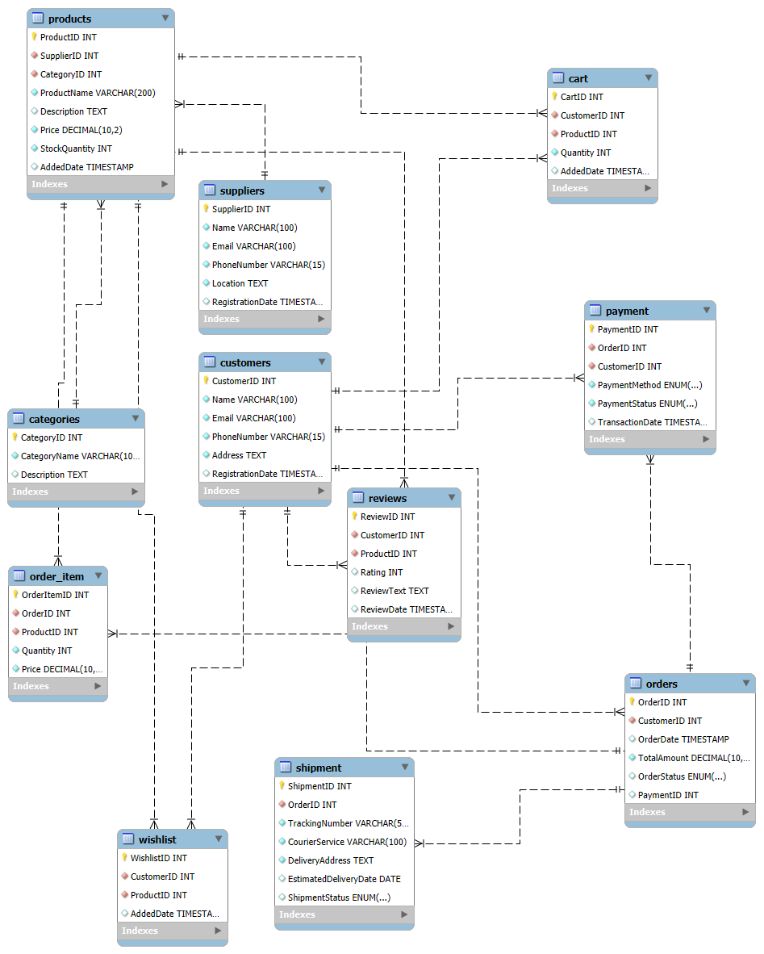

**Primary Key**

**Foreign Key**

### **Conclusion**

In this case study, we explored the design of Meesho's schema and Entity-Relationship (ER) diagram to understand how the platform efficiently manages its e-commerce ecosystem. Meesho has transformed the way small businesses and individual entrepreneurs sell products online, enabling them to reach a wider customer base with minimal investment. The platform’s data model consists of entities like Customers, Suppliers, Products, Orders, Payments, Shipments, Reviews, and Carts, among others.

By analysing this schema, we gain insight into how Meesho:

* Manages customer and supplier interactions efficiently.
* Processes orders and payments securely and smoothly.
* Handles product listings, categories, and inventories dynamically.
* Enables customer engagement through Wishlist, reviews, and ratings.
* Tracks shipments and deliveries to ensure timely fulfilment.

This well-structured database model ensures scalability, reliability, and seamless functionality, contributing to Meesho’s success in the competitive e-commerce industry.

**Video Link:** [Product dissection](Untitled%20video%20-%20Made%20with%20Clipchamp.mp4)